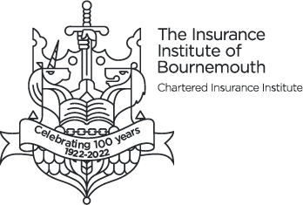

Rising Star Award Nominations - Now Open!


1st Place - £150 2nd Place - £100 3rd Place - £50.00

We are excited to announce that nominations for the Rising Star Award are now open! This award recognises and applauds the outstanding achievements of rising stars within our local Insurance and Financial Services Industry, covering the geographical areas of the BCP Area and into Dorset.

Do you know someone who fits the following criteria? Or perhaps it's you!

- Professionalism in Insurance and Financial Services: Has made a significant contribution to increasing “Professionalism in Insurance and Financial Services” within the local institute area or the local community.
- Sustainability: Can demonstrate a commitment and achievement towards a sustainability agenda to support the industry's goals in this critical area, either through their own job role or specific project engagement in the workplace.
- Diversity & Inclusion: Can demonstrate a commitment and achievement to support the industry's goals on diversity and inclusion, either through their own job role or specific project engagement in the workplace.
- Outstanding Performance: Has demonstrated outstanding performance within their role.
- Personal and Professional Development: Can demonstrate a commitment and achievement towards their own personal and professional development.

To view the full terms and conditions and find out how to nominate yourself or a colleague, please visit the Bournemouth CII Website 🌟 Rising Star Award Nominations Are Now Open – Celebrate Excellence!

Don't miss this opportunity to celebrate the rising stars in our industry!

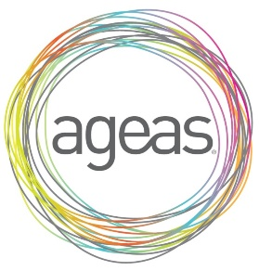

Sponsored by Ageas Insurance Limited

