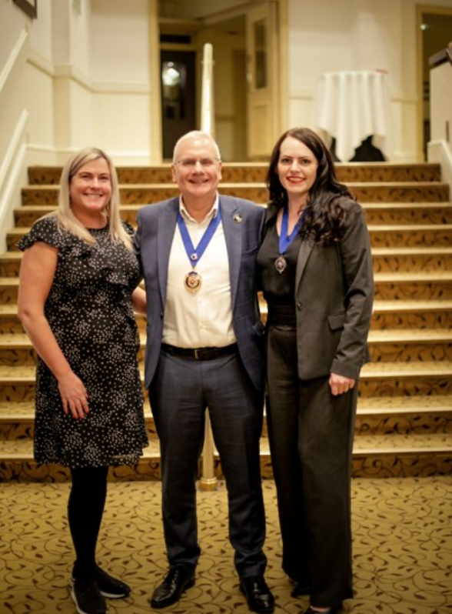
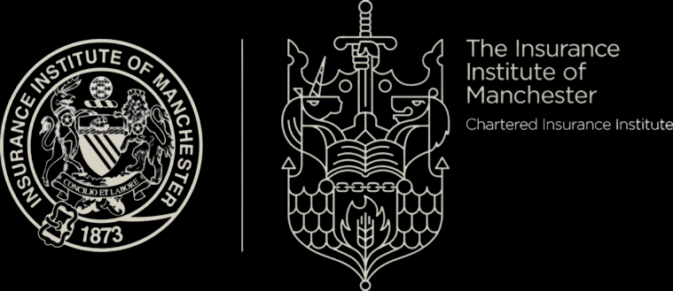
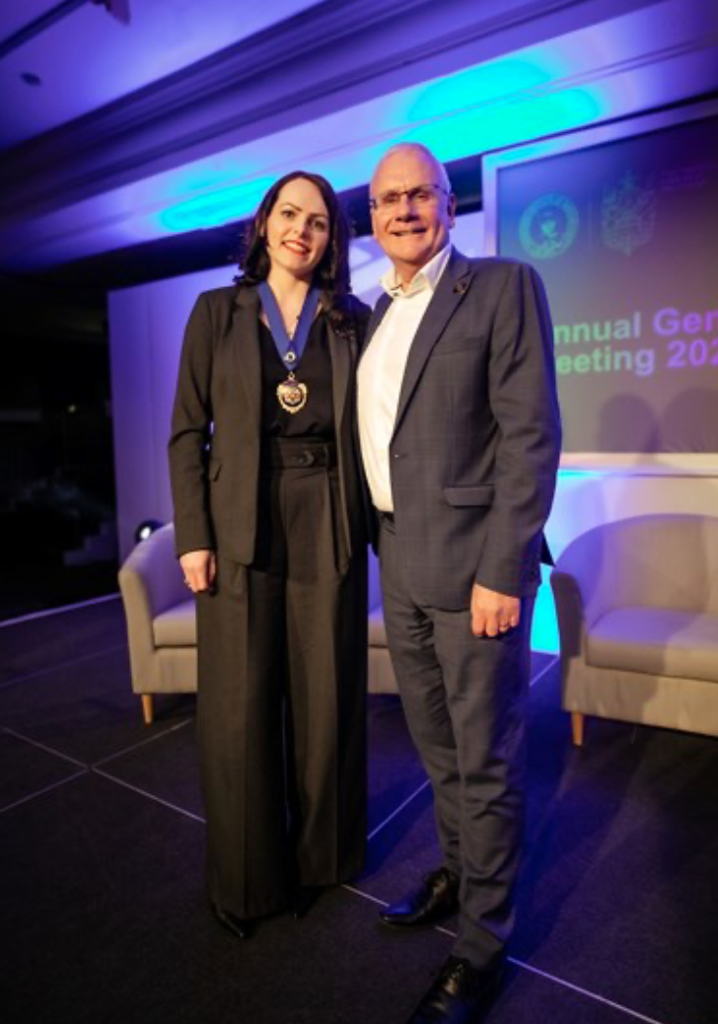
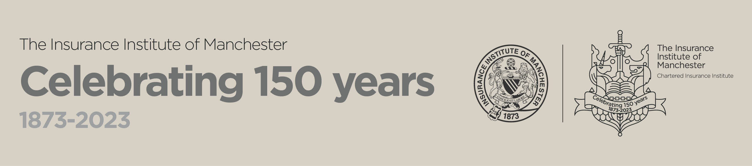

Annual General Meeting
Thursday 25th April 2024

Annual Report 2023-2024

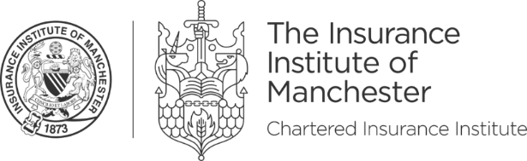
Contents

Programme 3
Local Institute Council and Officers 2023-2024 4
President’s Annual Review 2023-24 5
Sandra McDonald BA (Hons) Cert CII ACIM Cert CILA, President 5
Secretary’s Report 6
Nicola Cattan 6
Manchester Regional Forum Officer’s Report 7
Marc Hargreaves ACII 7
Charities Representative’s Report 7
Brad Jackson 7
Key Dinners Committee Report 9
Danielle Gowrie 9
Treasurer’s Report 10
Lisa Petherick ACII 10
Education & Development Committee Report 13
Ryan Conroy, Education Chair 13
CPD Committee Report 14
Eleanor Moore Cert CII 14
Events Committee Report 15
Christopher Lynch 15
MIIndful Manchester Committee Report 15
Karen Shenton ACII 15
Council Proposed President 2024-25 16
Stacey Sheridan 16
Thank you to our sponsors for 2023/2024 17
Thank you to our sponsors for 2024/2025 18

General information

Email: lii.manchester@cii.co.uk
Web: www.cii.co.uk/manchester
Facebook: The Insurance Institute of Manchester
LinkedIn: Insurance Institute of Manchester

Programme

- Welcome and President's Address
- AGM formalities
- Incoming President's goals and objectives for 2024-2025
- Cyber Panel Discussion

1 hour of continuing professional development can be claimed for this event if relevant to your learning and development needs.

149th Annual General Meeting of the Insurance Institute of Manchester 2024

The notice of the AGM and the copy of the 2023 minutes have been sent to members on email and also available via the website at www.cii.co.uk/manchester.

The existing Council recommends that members vote in favour of all the resolutions being proposed at the AGM, which they consider to be in the best interests of the Institute as a whole. We will vote en masse, however if there are majority of objections, we will vote separately for each point:

- The proposed President of the Institute for 2024/2025 is Stacey Sheridan of HSB Engineering

- The proposed Deputy President of the Institute for 2024/2025 is TBC

- To receive and adopt the Treasurer’s Report and Accounts for 2023

- To receive and adopt the Annual Report of Council for 2023/24

- To elect the following Vice-Presidents for the session 2024/2025
    - Under rule 8) Sandra McDonald, Paul Heathcote, Eleanor Moore
    - Under rule 8.4) Mike Cranny

- To elect the following ex-officio members of the Council for the session 2024/2025
Secretary: Emma Ackers, Empower Development
Treasurer: Lisa Petherick, Volkswagen Financial Services

Committee Chairperson(s) & Representatives:
CPD Chair: Nicola Cattan, McLarens
Education Secretary: Ryan Conroy, A J Gallagher
Events Chair: Chris Lynch, Ignite
MIIndful Manchester Chair: Adrian Golifer, Create Solutions Ltd
Dinner Secretary: Lydia White, HSB Engineering Insurance
Diversity Officer: Adrian Golifer, Create Solutions Ltd and
Andrew Panayiotou, Premierline
Regional Forum Officer: Marc Hargreaves, Zurich Insurance
Governance Chair: Katie Jackson, Griffiths & Armour
Liaison Officer: Eleanor Moore, Broadway Insurance Brokers
Communications Officer: Sandra McDonald, McLarens

To re-elect the following Council members (not in named positions) for the session 2024/2025: Dina Railean, Dan Whitehouse, Paula Parslow, Rebecca Vidler

- To appoint BDO LLP Accountants for the session 2024/2025

- Appoint a Charities Representative: Brad Jackson, Catalyst Claims

Confirmation of date & time of next AGM: TBC

Local Institute Council and Officers 2023-2024

President: Sandra McDonald
Deputy President: Stacey Sheridan
Vice Presidents: Paul Heathcote
Eleanor Moore
Fintan Griffin
Mike Cranny

Secretary: Nicola Cattan

Treasurer: Lisa Petherick
Governance Chair: Katie Jackson

Education Secretary: Ryan Conroy
CPD Committee Chair: Eleanor Moore
Key Dinners Committee Chair: Danielle Gowrie
Events Committee Chair: Christopher Lynch
MIIndful Manchester Chair: Karen Shenton
Regional Forum Officer: Marc Hargreaves
Charities Representative: Brad Jackson
Liaison Officer: Paul Hudson
Constitution Officer: Mike Cranny

Communications Officer: Dawn Derbyshire

Elected Members April 2023: Danielle Gowrie, Dina Railean, Dan Whitehouse,
Paula Parslow, Rebecca Vidler



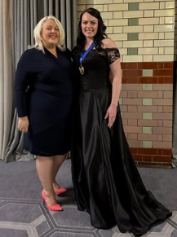
President’s Annual Review 2023-24

Sandra McDonald BA (Hons) Cert CII ACIM Cert CILA, President

Our original objective is “the promotion of a good understanding among the members of the insurance profession in Manchester.” Having a wide range of professionals, with a range of experience, from across insurance and financial services involved helps this happen. I would like to thank all our council and committee members who volunteer their time to organise our programme of events and keep the institute running. I would particularly like to thank for their support this year, Stacey Sheridan as Deputy President, and Eleanor Moore, as CPD Chair who have worked closely with me, and David Irvine, from the CII, for his guidance.

I have been fortunate to lead the institute in its 150th year, with the last AGM taking place at our celebratory conference at The Midland, which was followed in the evening by a dinner dance and our Jubilee Prize Awards for qualifications excellence. The efforts required to organise the 150th celebrations saw the council go above and beyond. The 150th highlights for me include the poem written by Mike Garry and his performance at the conference and our published Journal available on the website

To ensure the year had strategic direction, I had five objectives to focus on:

1. Map out potential support to encourage members to reach FCII -
The Education & Development Committee have taken on this project. We have confirmed that CII now have the capacity for us to undertake an FCII programme and I will continue to support this initiative to get it up and running.

2. Bring back the annual quiz joint with BIBA ✓
We held a successful quiz with BIBA and I hope this will now remain an annual key joint event.

3. Target key corporates for engagement ✓
4. Support SS on sponsorship packages for 24/25 to secure key events ✓
For the first time we secured annual sponsors to provide financial security for our key networking events. Thanks to McLarens, Acasta, Ignite, Nine St John Street, Touchstone Underwriting, Create Solutions, Zurich, Ten Insurance Services, Bravo Networks and Clegg Gifford. I’m delighted to say we have secured annual sponsor support for this new presidential year and we welcome HSB Engineering Insurance, Crawford and Clyde & Co on board.
We are actively looking for council members from a range of businesses and Eleanor Moore now steps into our Liaison role to continue this work.
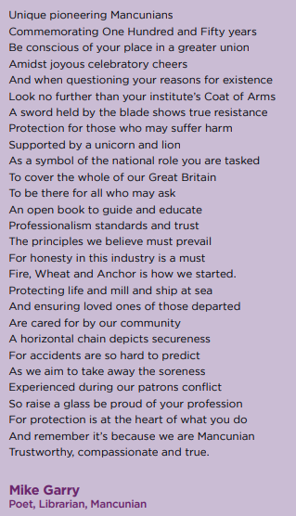
5. Raise £10k for ‘We Love Manchester’ Charity including fire walk ✓
It's been a pleasure to support the We Love Manchester charity and I’m delighted to say we have raised over £13,000 for them this year – it was well worth walking over hot coals to know we can help local people start careers for better futures!

Our committees have organised over 50 events this year! From our core CPD sessions covering compliance and new risks; to wellness sessions like the amazing in-person breathing techniques event; focussed career development sessions; even a Grease-themed Style in the City fashion show, there really is something for everyone. In developing relationships with other organisations we’ve held two joint events with AIRMIC and many of our social and networking events have been joint with BIBA and iCAN.

On behalf of all members, I would like to acknowledge the long service of retiring council members today. Mike Cranny, Karen Shenton and Fintan Griffin are stepping down from council today. All past presidents and pioneers, they have shaped this institute to be at the centre of insurance in Manchester. Thank you,

Finally, I would like to thank my employer, McLarens, for their unwavering support and I wish the new President, Stacey Sheridan, the very best for her year in office.

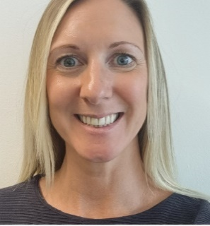
Secretary’s Report

Nicola Cattan

I joined the Insurance Institute of Manchester council in the role of Secretary in 2023 with an eagerness to support the council and committee members who work so hard to deliver quality to our members.

I have had great insight into the all the committees and how they operate. It’s truly inspirational to see the commitment and dedication of all and the passion to ensure that diversity and inclusion is at the forefront of all initiatives.

It has also been wonderful to see so many face to face events (CPD and social) throughout the year allowing the opportunity for the community to network. One thing is clear each year the committees strive for improvement and there are some great things planned for the year ahead.

I would like to personally thank Sandra McDonald for asking me to get involved and for having the foresight to utilise the services of Superstar PAs to support the administrative duties on behalf of the IIM. Hannah has been a true support to us all.

Membership figures as of April 2024

Council Members with Special Responsibilities


Manchester Regional Forum Officer’s Report

Marc Hargreaves ACII

As the Regional Forum representative, it’s my job to attend and represent the IIM at the CII Regional Forum. This is one of our direct routes into the CII at a national level and the aim is to ensure that the views and interests of the IIM are expressed and protected on things like funding allocation, exam issues and other organisational themes. We meet with the other Northwest institutes, the CII’s director of Local Institutes, and the Regional Membership Managers, to share ideas on best practice and to discuss issues. Our Northwest National Forum Officer will then report and represent us at a national level at the Local Institutes National Forum.

There has been a lot of organisational activity at the CII centrally resulting in the CII looking at many of the things it does from a financial perspective, such as relooking at grant allocations to address inequalities between large and small institutes, as well as looking into how they communicate more effectively with members and getting deeper into a few issues surrounding the provision of exams. At the Regional forum, we have contributed our thoughts, questions and challenges as befits one of the largest insurance institutes.

Overall, it has been an interesting 12 months in the regional forum. I have endeavoured to put the general views of the institute forward and “shown off” our excellent CPD offering and discussed the sesquicentennial celebrations.

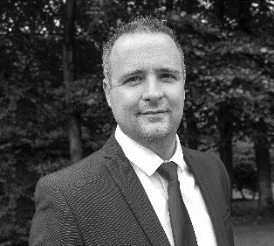
Charities Representative’s Report

Brad Jackson

The focus in the fourth year as Charities representative has been to continue to raising awareness of The Insurance Charites amongst current and former insurance employees.

Data from the charity advised there were 10 beneficiaries for 23/24 receiving awards of £69,996.06 within Manchester. 2 Summer hampers and 6 Christmas Hampers were also sent. There are currently 18 active beneficiaries in Manchester.
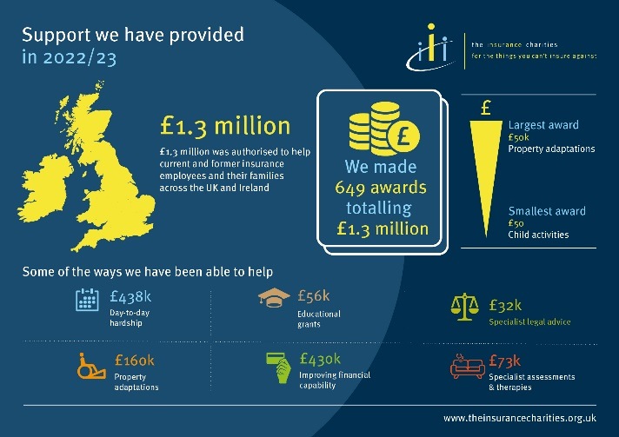
The charity does not only provide financial support, but they also provide a lifeline to people with difficulties they may be facing such as:

- Poor health
- Domestic abuse
- Relationship breakdown
- Depression
- Disability
- Financial problems
- Tragedy
- Redundancy

The Insurance Charities is a charity for the UK and Irish insurance profession, providing support for current and former insurance employees and their dependants since 1902. They give on average over £1million of help each year to insurance people in need.

Manchester is one of the larger regions, and therefore it is important to keep raising awareness across the various businesses based here in the city and surrounding areas, and this is an important part of the role. To qualify, a recipient needs to have worked for five years in insurance and in need of financial assistance. An applicant does not need to be a CII member to apply for help.

The Insurance Charities Awareness Week (ICAW) will run from 24 to 28 June in 2024. Last year the charity reached 31% more insurance colleagues than the previous year and saw applications for support increase following the campaign.

You can help by sharing the online posts on both LinkedIn and Twitter and can use the #ICAW in the lead up to the awareness week. The Insurance Charities have free giveaways for companies to distribute to employees. These can be ordered from https://www.theinsurancecharities.org.uk/order-your-awareness-week-giveaways-now/ up to the 17th May 2024. There will also be digital supporter toolkits to assist everyone get involved in the awareness week.

The Insurance Charities have a stand at the BIBA conference in Manchester on 15th and 16th May 2024.

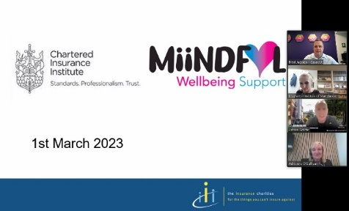
Below is a link to a webinar held in 2023. In this very informative and supportive session by The Insurance Charities:

- Adrian Golifer (Create Solutions) presented information on the cost-of-living crisis
- Adrienne O’Sullivan (Honorary President, The Insurance Charities) delivered a presentation and took a Q&A about the charity and what they do, she also explained the varying types of support that can be provided (not just direct financial support) and provided statistics on the support that has been provided recently.
- Brad Jackson (local ambassador for the Insurance Charities) explained how the charity helped him, he also talked about his personal experience, explained how the process works and why he became an ambassador for the charity.
https://www.localinstitutes.cii.co.uk/manchester/home/events/2023/miindful-manchester/how-the-insurance-charities-can-help-people/

If you are aware of any person in need of help and support and you think the Insurance charities can help, then please do not hesitate to contact me.

The IIM donated £500 to the Insurance Charities along with £2700 raised at the Style in the City event on 23rd June 2023 which was donated to the Presidents chosen charity We Love Manchester. The charity gives heart, hope and opportunity to the people of Manchester, when they need it most. They provide direct support to address the challenges of children living in poverty and growing up with few qualifications, by spreading opportunities and helping communities to build themselves up.

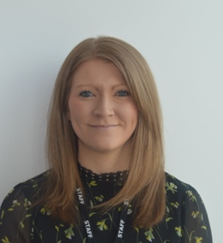
Key Dinners Committee Report

Danielle Gowrie

In 2023 it was a pleasure to launch our annual sponsor packages, which included sponsorship to our two biggest events of the year, Style and the City and our Annual Dinner. Thank you to our 2023 sponsors for making the events possible.

Platinum: McLarens

Gold: Zurich, Ten Insurance Services, Ignite, NineStJohnStreet, Touchstone Underwriting, Create Solutions, Acasta Europe

Silver: Bravo Networks, Clegg Gifford

The Style in the City fashion show took place on Friday 23rd June at the Midland Hotel. We had 349 guests attending the 50s Grease themed lunch in support of the We Love Manchester charity. Thank you to our additional Style in the City sponsors, Protector Insurance, HSB, Travellers and Arch Insurance for their support.

We had nine brave insurance industry models strut their stuff on the catwalk: Andrew Panayiotou, Hannah Ebbitt-Ngang, Sam Drysdale, Adrian Golifer, Rebecca Webster, Martin Cleary, Zoe Thompson, Ian Bradford, Georgia Sheils. Wearing clothing provided by Fizz Fashion with hair and makeup by White Rose. The afternoon was finished off with dancing to DJ Dave and then the usual after party at Revolucion de Cuba. The event raised £2,770 for the charity in profit. Overall, the event went well, and a post-event survey has positive feedback.

The Annual Dinner took place on 10th November 2023 at the Kimpton Clocktower Hotel, hosted by the President Sandra McDonald. As Sandra’s chosen charity for the year was, We Love Manchester, the event was Manchester themed with lots of love hearts to represent the charities logo. Many thanks to our annual sponsors as well as our additional dinner sponsors, Arch Insurance, Great American Insurance, CAN Hardy and Hawkins Associates. After a traditional three course meal, guests enjoyed entertainment from our comedian Daliso Chaponda, Oasis tribute band Supernova followed by DJ Dave into the early hours of the morning. The event raised £2,221.66 for charity and received outstanding feedback from all guests in attendance.

I would also like to thank my employer, Protector, for the time they have allowed for me to work for the committee and the institute. Style in the City 2024 is already sold out for 28th June at the Midland Hotel. Tickets for the Young Members Ball in September, the Annual Dinner in November will go on sale soon.

The committee thank you for your support and look forward to seeing you at the upcoming events.

Committee Members:
Danielle Gowrie (Chair), Lydia White (Deputy Chair), Stacey Sheridan, Laura O’Connor, Paul Heathcote, Jimmy Reynolds, Hannah Muldowney, Jasprit Sihra and Siobhan Crompton.

Institute committees:

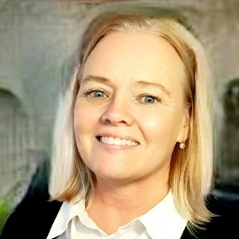
Treasurer’s Report

Lisa Petherick ACII

It was pleasing to see that 2023 was significantly busier with events than the previous few years and that appetite is returning for face to face events. Hosting events is key for us to utilise the grant received from the CII effectively for our members and we are keen to offer courses which offer valuable learning experiences, whether this is to help with exams or on individual topics.

Greater focus is now placed on our mental health, both in and out of the work place and the Mindful committee work hard in providing thought provoking sessions, which compliment our technical subjects.

A significant spend in 2023 was the 150th Celebrations, which consisted of a Day Conference and Dinner. Both were well received and we were able to offer a variety of speakers that offered attendees the opportunity to gain some meaningful CPD hours & valuable networking opportunities.

The total spent by IIM for 2023 exceeded the grant provided, mainly due to the significant costs incurred from running the conference. This loss was planned and has been part of our strategy to reduce our reserves for some time.

The IIM receives an annual grant from the CII which is based on several factors, including member numbers & performance to certain standards. The IIM can then use the grant money to fund CPD events, which include educational courses, seminars and networking events. Traditionally the IIM has benefitted from having very low operating costs, which lead to a grant surplus for several years.

The CII therefore do not pay us a full grant as we can utilise reserves from other years to fund events. The aim of the IIM is to keep hosting events to bring reserve levels down so that eventually our grant payment increases to the full level, but this will involve running at a loss for a few years. Our reserves are at such as significant level that we have several years’ operating costs to continue in this way.

Accountant's Report to The Insurance Institute of Manchester
Financial Period 1st January – 31st December 2023
We have examined the books, accounts and documents presented to us of Insurance Institute of Manchester for the year ending 31st December 2023 and have produced the attached set of reports and accounts for this period.

BDO LLP
3 Hardman Street
Manchester
M3 3AT

As follows:

- Balance Sheet – Year End 2023
- Profit and Loss – Year End 2023

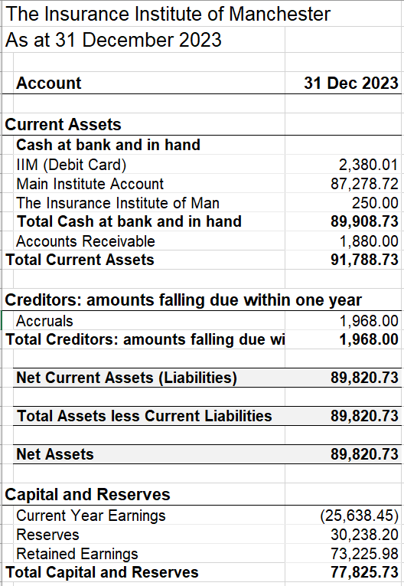

Profit and Loss
The Insurance Institute of Manchester
For the year ended 31 December 2023

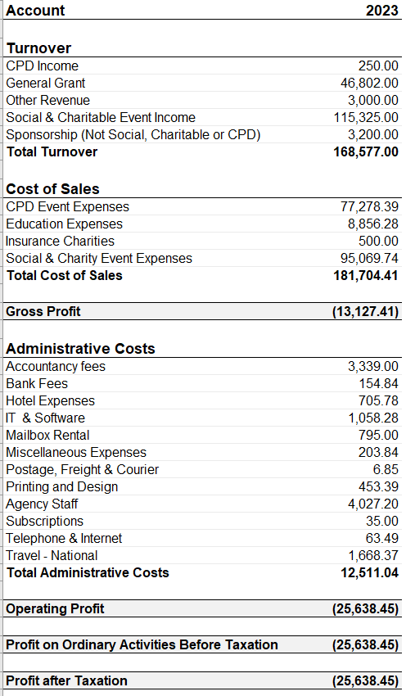
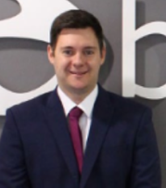

Education & Development Committee Report

Ryan Conroy, Education Chair

The Education and Development committee consists of 10 committee members. Emma Ackers deputises the committee. I would like to thank all of the committee members for their support this year in achieving our goals in another challenging year.

Jubilee Prize Awards 2023

The Annual Jubilee Prize award event was one of the highlights of the year for the committee. Normally this is a stand-alone event however, this year we incorporated it with the Institutes 150-year celebration at the Midland Hotel.

The award ceremony is to celebrate the outstanding success of the prize winners who gained the highest scores in the CII examinations. Congratulations once again to the winners of 2023 and thank you again to the sponsors listed below.

Award | Winner | Sponsor
Best Cert CII performance | Alice Selby | Reich Group
Insurance Law | Stacie Warrington &  Ross Aveyard | ITP
Insurance Broking Practice | Claire Howarth | Bridge Insurance Brokers
Claims Practice | Rebecca Taylor | Sedgwick
Insurance Business and Finance | Lucy Stansfield | Empower Developments
Liability Insurances | Jane Drummond | IIM
Underwriting Practice | Rebecca Taylor | IIM
Commercial Property and Business Interruption | Michael Scarrott | BIBA
Risk Management | Mohammed Abdul Majid | IIM
Best Dip CII performance | Ben Martin & Andrew Hamspson | Griffiths & Armour Insurance Brokers
Advanced Claims | Neil Jolly | Carolyn Bowers
Best ACII completion | Russell Smith | McLarens

Insurance Careers

One of the Education and Development Committees commitments was to increasing engagement with local schools and colleges to promote carrers in the Insurance industry. Over the past year, members of the committee have attended careers events at schools and colleges in the Greater Manchester area:
- Emma Ackers and Rebecca Vidler attended a career fair at Marple High school in May 2023
- Emma Also attended Marple Hall High School careers fair with BIBA on 21st June.
- Ryan Conroy represented the committee at Hazel Grove School in Oct 2023 as well as Lazarus School in Cheadle alongside colleagues from BIBA
- Emma Ackers attended two sessions at Trafford College 1^{st &} 7th Feb 2024

As 2024 progress, the committee continues to promote the Manchester insurance market and insurance in general through assisting with careers fairs. We will also be looking to make further contact with local schools and colleges over the next year and will be looking for new opportunities to promote the insurance industry as a career for school leavers.

Fast Track ACII & DIP

Our Fast Track ACII program & Fast track Dip has continued to run successfully throughout 2023, with thanks to ITP. We hope to complete both fast tracks at the end of 2024.Afterwhich we will consider running fresh programmes.

The Leadership Programme 2024

The Development Programme is a subcommittee of the Education committee, ran by Hokey Chik, Sam Baxter both of which are previous course attendees.

With the success of previous programmes, it was decided at the end of last year that we would put on a similar programme for 2024, titled the Leadership Programme. This would have a focus on developing the member’s career and giving the attendees the tools needed which they may not necessarily be able to obtain, during their normal day to day job.

Due to the pandemic, previous courses have run virtually however we have decided to hold the future course on a face-to-face basis.

Hokey Chik and Sam Baxter for taking an active role in moving this programme forward and look forward to a successful programme run this year.

Committee Members:
Ryan Conroy (Chair), Emma Ackers (Deputy Chair), Sam Baxter, Hokey Chik, Mark Farrant, Libby Empson, Korey Amusa, Emanul Islam, Elisha Snape Rebecca Vidler.

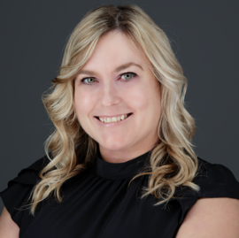
CPD Committee Report

Eleanor Moore Cert CII

In the last year, we have offered a programme of technical topics, soft skills, and revision support, which has been well received. Attendance is still not at the levels that we would like to see but we are hoping that by recording CPD sessions, we can create a library for members to access at a time to suit them.

In-person events have been increased and have been well attended, with a networking element included each time. The in-person events have proven successful at appealing to insurance and PFS members equally and we look forward to continuing to offer these in the forthcoming year.

IIM Bitesize is a new initiative, which was introduced to dissect the various areas of the industries and to provide an overview and insight in basic terms. This is aimed at those new to insurance and financial services and those who wish to diversify their knowledge.

We have delivered 32 hours of CPD in the last year and are looking to increase this going forward.

We have had a variety of speakers from across the industry and I would like to take this opportunity to thank them all. I would also like to thank the committee members who volunteer their time to build and deliver the CPD programme. Thank you to Andrew Hope, Paul Heathcote and Jordan Haskayne who have stepped down from the committee.

If anybody has any ideas for topics, please feel free to get in touch with any committee member.

Committee members:
Eleanor Moore (Chair), Janet Penny, Marc Hargreaves, David Swali, Judith Simister, Daniela McGowan and Emma Ackers.


Events Committee Report

Christopher Lynch

2023 wasn't the strongest year for the Events Committee, with poor traction on events and slow committee engagement, however we are positive that 2024 will be the year!

July did see us host the ubiquitous football tournament and it was great to see so many old faces and new teams alike. So much so, this year’s tournament is being held next week with the same success.

We hosted a walking tour in Manchester in September, which was a reasonable success. The walk took us around interesting landmarks of Manchester and it's surprising how much you still learn about your city!

October saw us engage in a battle of wits in a joint IIM and BIBA Quiz. The event was a great success with excellent attendance. The winners on the night were my very own Ignite Team!

We stepped up to the oche at the end of March for our first social of 2024. It was a fantastic night of darts, and it was amazing to see a younger audience engaging with the Institute. Certainly, food for thought for 2024/25 with the events committee. The winner on the night was the committee's own Rachel Birkett. I think these low-key, low-cost events are a definite fixture moving forward.

As I said, 2023 wasn't the best year for the Events Committee, but we're confidence with some renewed energy and new members, we're in a good place to put on a full and engaging schedule for 2024/25. Key to this is linking up with other associations for example iCAN and BIBA. This is to help promotion of key events and share resource and energy as a wider Manchester networking team.

Committee Members:
Chris Lynch (Chair), Rachel Birkett (Deputy), Richard Townsend, Richard Bates, Isabel Norman, Michael Boyd, Natalie Albert, Alex Moore.

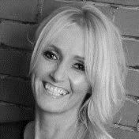
MIIndful Manchester Committee Report

Karen Shenton ACII

Its almost 4 years since we launched the Miindful Manchester Committee. We have delivered a number of online CPD events throughout the year to promote wellbeing in our industry.

Miindful Manchester provides help for individuals and members, but it can also be a useful resource for firm in helping and supporting their staff.

There has been an increase in physical and mental illness and generally people needing support. There are many organisations and charities offering invaluable help and support to people (We have some listed on our website) so please take a look.

We are here to help too. Our group is made up of people who work in the industry and who have a passion and interest for wellbeing and for helping others. We meet once a month to discuss current issues, look at how we can help our members and organise relevant events.We have been busy again this year and here are some of the highlights of what we have been up to.

We are delighted to announce that the Insurance Institute have also launched a Programme of sessions delivered by Jonathan Bates from Breathworks. In these sessions Jonathan provides tools and techniques to manage stress more effectively and improve overall emotional health. Our industry can be fast-paced and often stressful in nature. This program is a great opportunity for participants to benefit from overall wellbeing whether it be within the workplace, or on a personal level. 12 monthly sessions, lasting 30-45 mins and they include a practice such as meditation. Participants will also be provided with guidance on how to bring mindfulness into their daily lives. Some other topics and events we have held are below:

Date | Topic and Speaker
16th May 2023 | Dealing with Anxiety: How to Avoid Burnout and Prioritise Self-Care - Jodie Hill Thrive Law
26th July 2023 | Managing Menopause - Emma Dechoux
4th September 2023 | Focus:Most Important Skill of the 21st Century - Sha Hussain, Wellness movement
11th September 2023 | World Suicide Prevention Day - Conversations around self-harm & suicide - Helen Pettifer
27th September 2023 | The committee received Mental Health First Aid training – David Cain, Prevention through Connection
22nd November 2023 | Face to Face Networking event (Jointly organised by the CPD and Miindful committees) Discover your Superpowers - Danny Donachie
15th December 2023 | Introduction to Mindfulness and meditation - Johnathan Bates, Breathworks
15th January 2024 | 2024: The Year to Look After Your Mental Wealth. Find out how! - David Cain
13th March 2024 | A Sleep Well Workshop - Lisa Kempster, Bestyouhealth.
Plans for the forthcoming year ….

As a committee we are extremely excited for the plans we already have in place for 2024/25.

If you are interested in joining us or finding out how you can get involved, please contact the IIM office or contact Adrian Golifer Adrian.golifer@createsolutions.co.uk
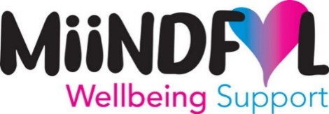
We would love to hear from you. You may have some great wellbeing initiatives happening in your organisations. Don’t be shy. We are happy to hear about them and share ideas and see if there are any way we can collaborate in promoting WELLBEING.

Committee Members:
Karen Shenton (Chair), Adrian Golifer (Deputy Chair), Andrew Panayiotou, Cath Hulme, Claire Smith, Ellis Sweeney, Jonathan Bates, Jordan Haskayne, Jordan Hurst, Scott Winn, Simon Derbyshire, Rebecca Vidler and Rhi Caddy (MAT).

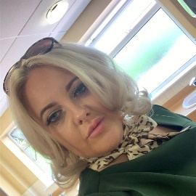
Council Proposed President 2024-25

Stacey Sheridan

I have enjoyed my year as deputy president with the IIM.
Working closely and supporting Sandra as president will ensure a smooth transition into my presidency and carrying on with the great work Sandra has done. During this last year I have also had time to work closely with our committees and council members.

Thank you to our sponsors for 2023/2024

Platinum
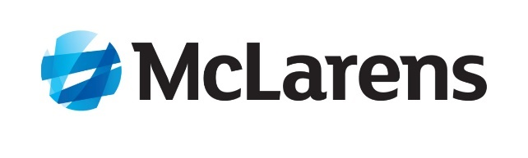

Gold

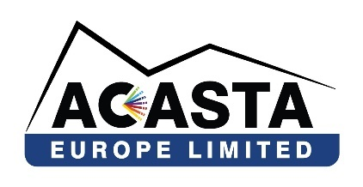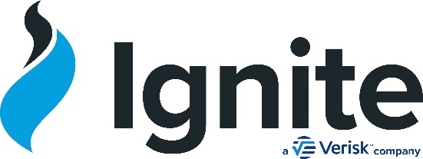

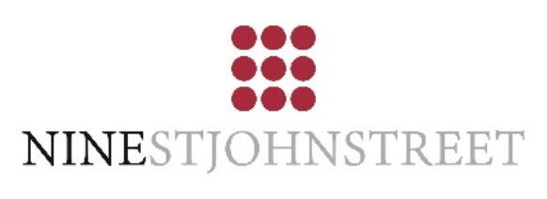



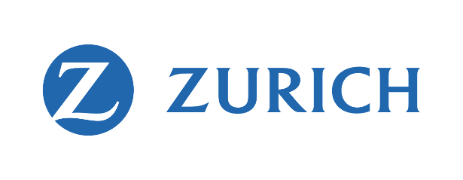

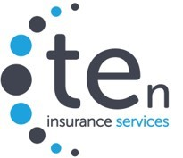

Silver
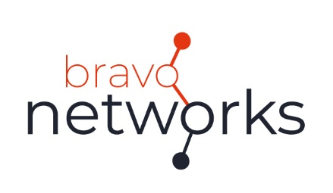



Thank you to our sponsors for 2024/2025

Platinum


Gold

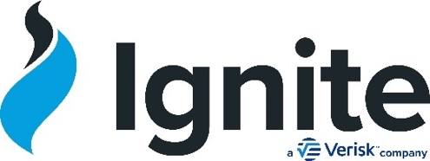

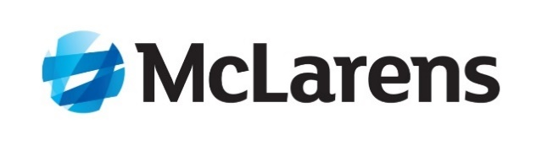

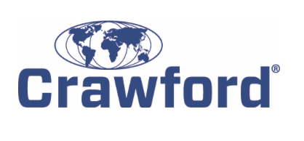
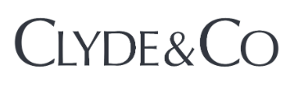

Silver

